

*Operating System*  
*Lab 04*

Name : Muhammad Shamoil  
Section : BSSE – V – A  
Date: 17th October , 2025  
Submitted To : Maam Seemab

# Task 1

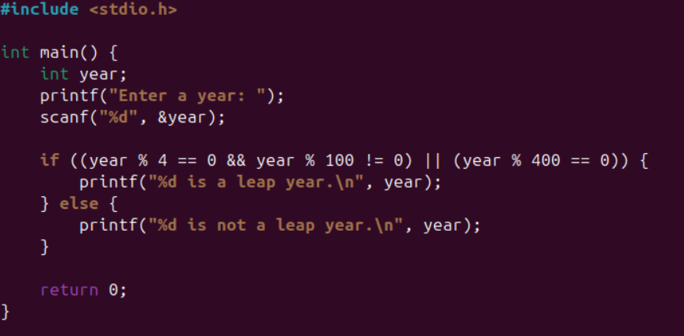

# Task 2

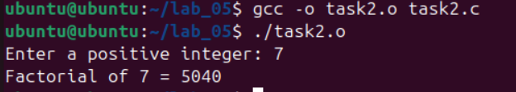

# Task 3

# Task 4

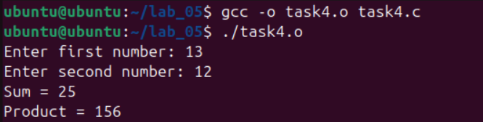

# Task 5

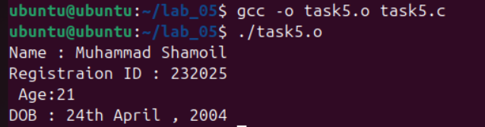

# Task 6

